Bank Loan Dataset

* Check the quality of the Data:
* There are some missing values or null values in Empty title, no problem for the data analysis.
* It’s not necessary here for working all the people who has taken the loan and some people are not comfortable for sharing their Employment details.
* Power Query shows the 1000 rows only at a time.
* ID columns is primary key here, all the values are unique and not null values
* Close and apply

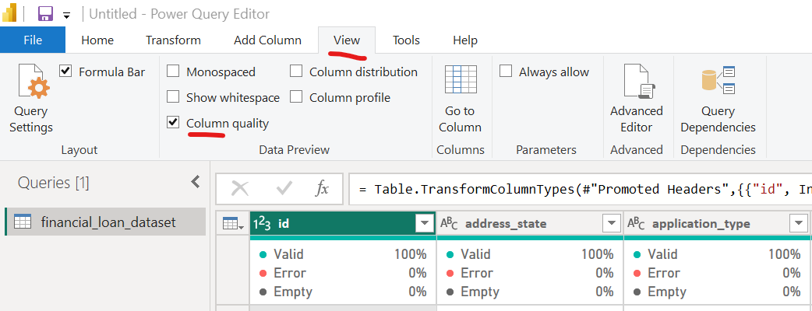

* Column Distribution:

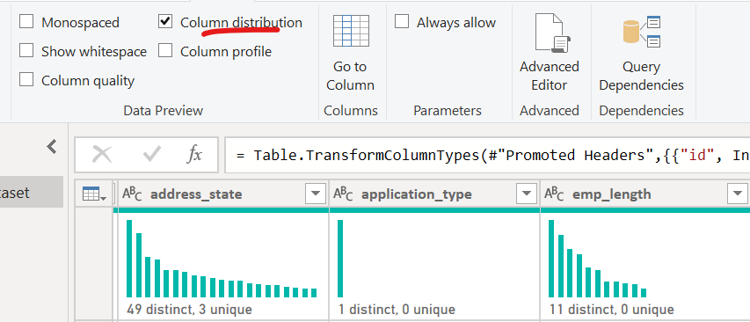

* DAX function called as time intelligence function, Create a date table with the help of New Table

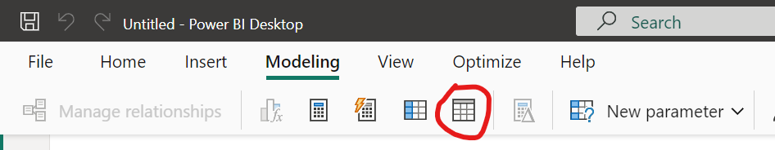

* There are two function to create a date table

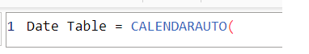



1. Create a date table, start date and end date of issue date.



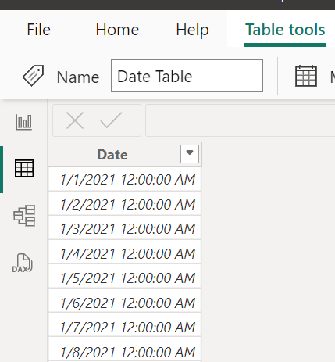 It will take all the date from min date to max date for all day date whether the data has the date or not. Each row is unique

1. Create a new column for month.

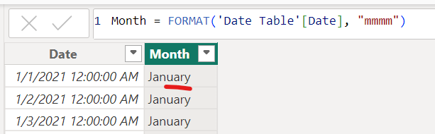

1. There is no relation between this table and the data we have. Click to Data Model

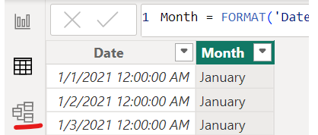

1. Total Loan Applications: Take a card 123



Calculator icon shows the field has been created by manually



1. Month to Date Loan Application:

"Month-to-Date Loan Application" refers to the total number of loan applications received from the beginning of the current month up to the current date.



1. PMTD Loan Applications:

PMTD Loan Applications" stands for "Previous Month-to-Date Loan Applications. It measures the number of loan applications received from the beginning of the previous month up to the same date as today. This metric is often used to compare current performance with last month's performance up to the same day.



If today’s date is October 12, the formula calculates the total loan applications from September 1 through September 12.

Filter condition – Dates MTD 🡪 Is is a time intelligence function, Returns a set of Dates in the month up to Current Date.

Date add 🡪 Moves the given set of dates by a specified interval.

-1 🡪 number of intervals, one month back

Month 🡪 for month

1. MOM Loan Applications: Percent increase in the loan applications in current month received compared to previous month loan application.

"MOM Loan Applications" stands for "Month-over-Month Loan Applications." It is a metric that compares the total number of loan applications received in one month with the total received in the previous month. This can help to identify trends or shifts in application volume on a month-to-month basis.

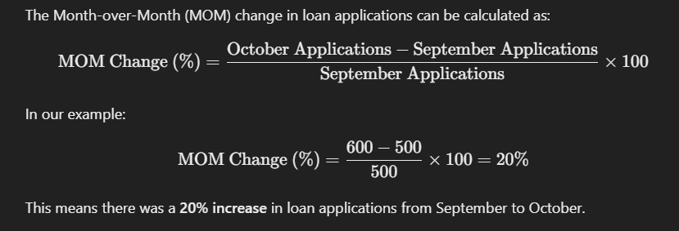



MOM = MTD value – PMTD value/ PMTD value

The **Month-over-Month (MOM) Loan Applications** measSure calculates the percentage change in loan applications between the current month-to-date (MTD) and the prior month-to-date (PMTD).

* Each row in the date column has a unique value, encompassing all days between the minimum and maximum issue dates. This ensures that every date within this range is represented. Additionally, it is verified whether each date falls within the specified date range.
* Create new column for Month date and month number
* There is no relation between the date table and the dataset.
* Total Funded Amount:



* MDT Funded Amount:



* PMDT Funded Amount:



* MoM Funded Amount:



* Total Amount Received:
* Avg interest Rate:



* MTD Average Interest Rate:



* PMTD



* MOM



* Avg DTI: Dept to income ratio

In the context of loans in the USA, **DTI** stands for **Debt-to-Income Ratio**. It’s a measure lender use to determine an individual's ability to manage monthly payments and repay debts. The DTI ratio compares a borrower's total monthly debt payments to their gross monthly income and is expressed as a percentage.

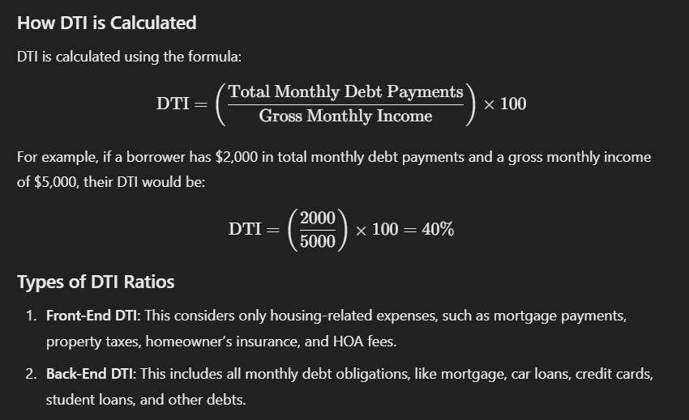

Why DTI Matters

Lenders in the U.S., such as mortgage companies, typically have a maximum DTI limit, often around 43% for mortgages. A lower DTI ratio indicates better financial health and less risk for the lender, making it easier for borrowers to qualify for loans.

* Average DTI:



* MTD DTI



* PMTD DTI:



* MOM DTI:



* Good Loan VS Bad Loan KPI’s

Create the group for Good and Bad loan

Right click on Loan Status and select New Group

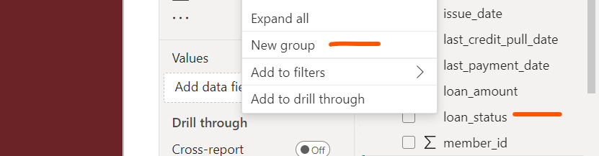

Select Fully Paid and current and create group

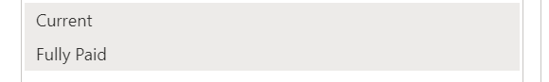 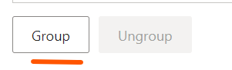

Double click and name the group

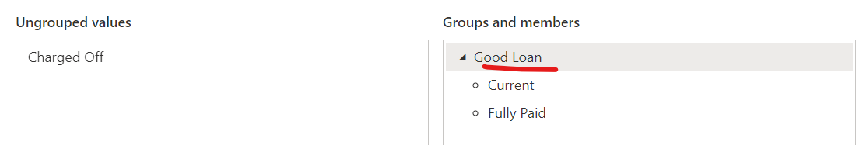

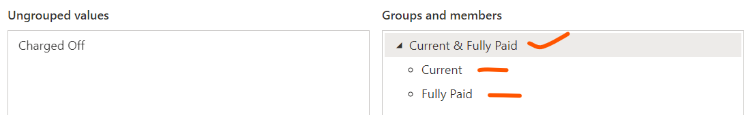 

New field has created



Right click and Edit the group named Good VS Bad Loan

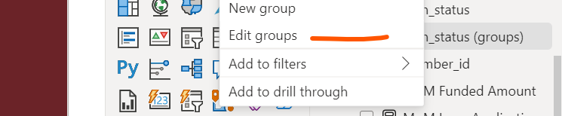

Select the Donut chart

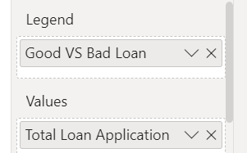 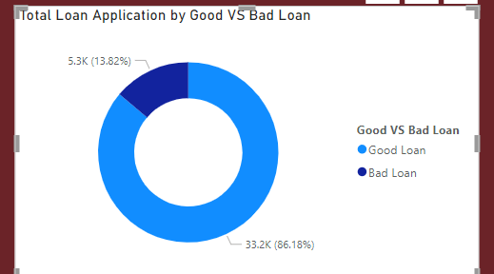

Create a new measure for good vs bad loan application

* Good Loan % :



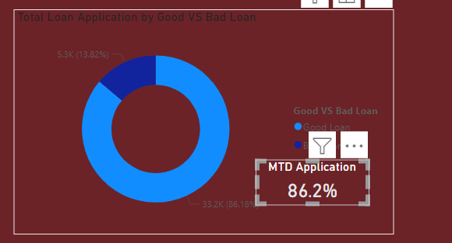

* Good Loan Application:

  

New card for visual

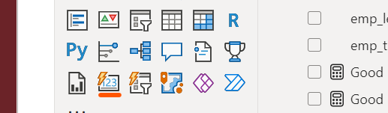

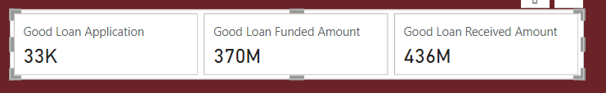 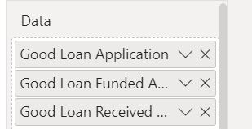

* Bad Loan:

Same as for bad loan

  

* Another way to create find out the number of Good Loan and Bad Loan

Good Loan Percentage and Bad Loan Percentage

Good Loan Count = Calculate the Count Fully paid Loan and Current Loan











Line chart | Monthly Trend

We have to show the 3 metrix

Total Loan Application | Total Funded Amount | Total Amount Received

Step 1: take month from date table on x-axis

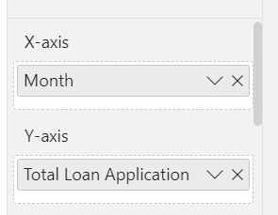 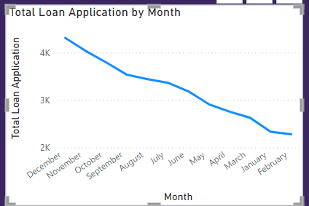

The charge has been created but we cannot change y-axis,

Need to create the filed parameter to make it more dynamic,

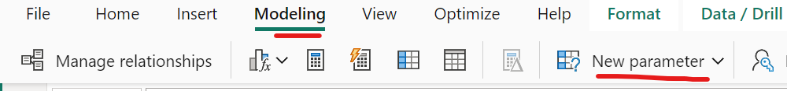

Go to modeling 🡪 New Parameter 🡪 Field

Give the name and select the parameter you will use to filter the data.

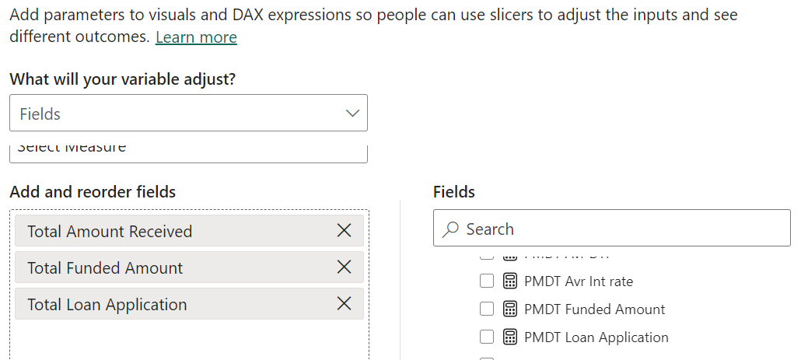

The slicer has been created

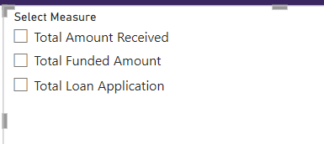 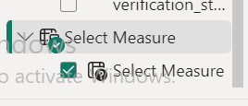

By selecting this, it is not changing the line graph,

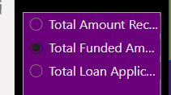

Select the select measure and put into y-axis

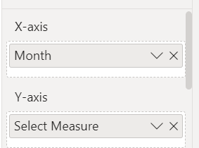

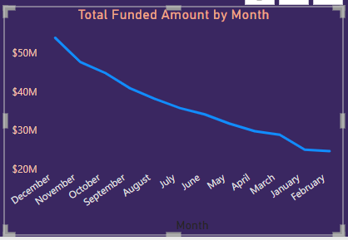

Go to date table 🡪 mmmm to mmm

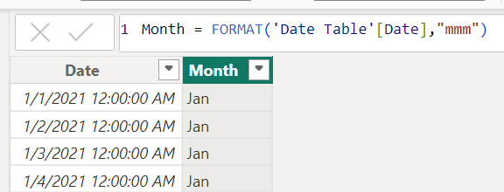 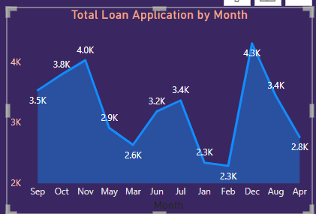

Create a one more column 🡪 month number

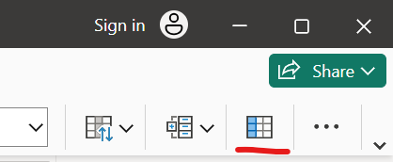

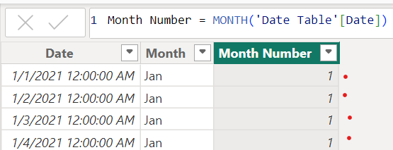

Sort the axis

Select month column – go to column tool – sort by column – sort by month number

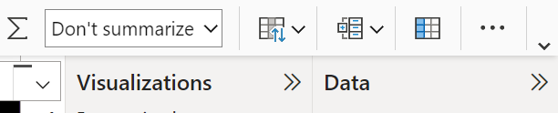

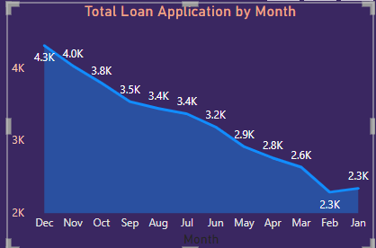

We want it ascending order

